**MySQL**

SQL – structure query language



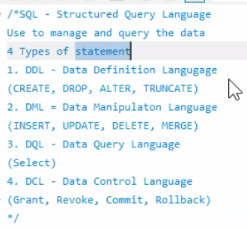

* Show databases 🡪 it will show all databases
* Show tables 🡪 it will show the the tables
* Use databasename 🡪 it will use data base which is given
* Order by asc or desc 🡪 it will show assending and descending order
* Limit 10 🡪 it will show first 10 records
* Limit 10,15 🡪 it will skip 10 records from 11th to 15th record will get it
* Limit 10 offset 5 🡪 offset help in skipping, skip 5 records and display from 6th to next 10 records
* Select concat(firstname,” “,lastname) as full name 🡪 it will concat first and second name
* Select distinct(columnname) from tbalename 🡪 gives unique vaues
* select now() datetime 🡪 display date and time
* select current_date() 🡪 display date
* select current_user() 🡪 display current user name
* where columnname is null 🡪 gives null values
* where columnname is not null 🡪 except null will get everything
* where columnname in ( 1,2,3,”aksha”,”Sudh”) 🡪 if present it display
* where columnname not in ( 1,2,3,”aksha”,”Sudh”) 🡪 except these everything it will display
* and / or operators we can use for where conditions
* >, <, >=, <=, = , !=(not equal), <>(not equal) 🡪 relational operators

**Wild cards**

* Select * from employee where name like “ak%” 🡪 will get all name which starts from “ak”
* Select * from employee where name like “%ak” 🡪 will get all value which ends from ak
* Select * from employee where name like “%ak%” 🡪 will get all value where ak is between the word
* Select * from employee where name like “a%y” 🡪 will get the value where the word starts from a and end with y
* Like “__A%” 🡪 output which has third letter a

/*show databases*/  
  
/*create database ustglobaldb*/  
  
use classicmodels;  
/*use cdb;*/  
show tables;  
desc employees  
  
select * from employees  
select * from orders  
  
select firstName, lastname from employees  
  
select concat(firstname, " ", lastname) as "Full Name"from employees  
  
select now() datetime  
  
select current_date()  
  
select current_user()  
  
select * from offices  
  
select country, city, state,territory from offices order by country   
select country, city, state,territory from offices order by country desc  
  
select country, city, state,territory from offices order by country asc , city desc  
  
select country, city, state,territory from offices order by country desc , city asc  
  
select country, city, state,territory from offices order by state desc  
from orderdetails limit 10 offset 5

#filtering  
select * from orders where status = 'shipped'  
  
select * from orders where status = 'shipped' order by orderdate limit 10  
  
select * from employees where jobTitle = 'VP Marketing'  
  
select distinct jobtitle from employees  
  
select firstname,lastname from employees where jobTitle in ('President','VP Sales', 'Vp Marketing')  
  
select firstname,lastname ,jobtitle from employees where jobTitle not in ('President','VP Sales', 'Vp Marketing')  
  
select firstname,lastname ,jobtitle,officecode from employees   
where   
jobTitle not in ('President','VP Sales', 'Vp Marketing')  
or officecode  = 1

select firstname,lastname ,jobtitle,officecode from employees   
where   
jobTitle not in ('President','VP Sales', 'Vp Marketing')  
and officecode  = 1  
  
select * from orderdetails where quantityordered > 50  
  
select * from orderdetails where quantityordered < 50 and priceEach >= 75  
  
/* > < = <= >= != */ **Relation operators**  
  
select  * from offices where addressline2 is null  
select  * from offices where addressline2 is not null and state is null  
  
  
select firstname , lastname, jobtitle,reportsto  
from employees  
where jobtitle in ('President', 'VP Sales','Sales Rep')  
and reportsto is null  
  
select firstname , lastname, jobtitle,reportsto  
from employees  
where jobtitle not in ('President', 'VP Sales','Sales Rep')  
and reportsto is not null

select * from products where productName like 'America%'  
select * from products where productName like '%bus'  
  
select * from products where productName like '%pickup%'  
  
select firstname, lastname from employees   
where firstname like 'M%N'  
  
select firstname, lastname from employees   
where firstname like 'L%e'  
  
select productName from products where productname like '_____A%'  
  
select firstname, lastname from employees   
where firstname like '__r%'  
  
select firstname, lastname from employees   
where firstname like '__rr%'  
  
select firstname, lastname from employees   
where firstname like '__r_r%'  
  
select firstname, lastname from employees   
where firstname like '%r__d'  
  
select firstname, lastname from employees   
where firstname like '____y'  
  
select firstname, lastname from employees   
where firstname like '%y'  
  
select firstname, lastname from employees   
where firstname not like '____y'

select productname,productcode from products where productcode like '%\_20%';  
  
  
select * from orders where orderdate >= '2003-01-01'  
and orderdate <= '2003-03-03'  
  
select * from orders where orderdate  between '2003-01-01' and '2003-03-03'  
  
  
select productcode, productname, buyprice  
from products  
where    
buyprice between 90 and 100  
  
select productcode, productname, buyprice  
from products  
where    
buyprice not between 90 and 100  
  
select ordernumber,  requireddate,status from orders  
where status in ('Shipped','In Process')  
and   
requireddate between '2003-01-01' and '2003-03-03'

select count(*) from orders;

select count(*) from orders

where shippedDate is not null;

select count(shippeddate) from orders;

select count(distinct shippeddate) from orders;

select count(status) from orders;

select count(*) from orderdetails;

select sum(priceeach) as sum, max(priceeach)as max,min(priceeach)as min,avg(priceeach)as avg, count(priceEach) total_count from orderdetails;

select officecode,firstname,lastName from employees

group by officeCode

**joins**

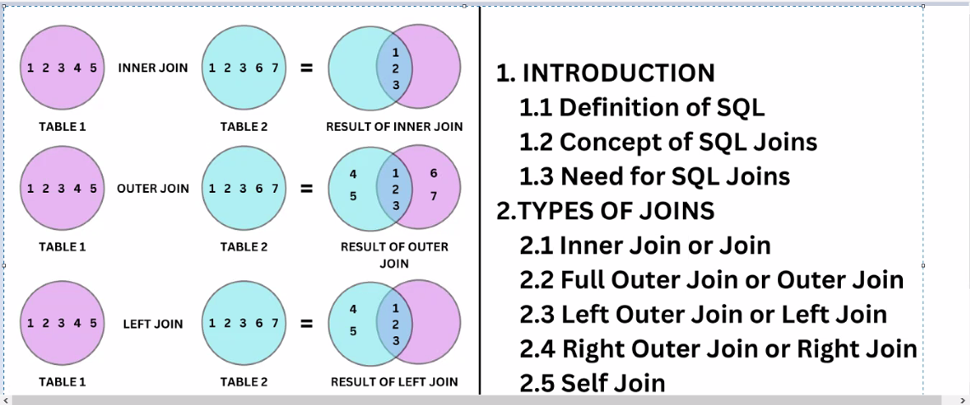

**In corelated subqueries**

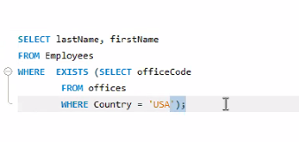

**Rollup:** where it will create the table using the select statement

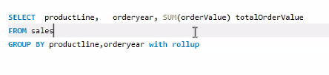

use classicmodels;

SELECT CUSTOMERNUMBER, CHECKNUMBER, AMOUNT FROM PAYMENTS

WHERE AMOUNT = (SELECT MAX(AMOUNT) FROM PAYMENTS);

SELECT CUSTOMERNUMBER, CHECKNUMBER, AMOUNT FROM PAYMENTS

WHERE AMOUNT > (SELECT AVG(AMOUNT) FROM PAYMENTS);

SELECT CUSTOMERNAME FROM CUSTOMERS WHERE CUSTOMERNUMBER NOT IN (SELECT DISTINCT CUSTOMERNUMBER FROM ORDERS);

SELECT MAX(ITEMS),MIN(ITEMS),FLOOR(AVG(ITEMS)) FROM (SELECT ORDERNUMBER,COUNT(ORDERNUMBER) AS ITEMS

FROM ORDERDETAILS GROUP BY ORDERNUMBER) AS LINEITEMS;

SELECT PRODUCTNAME,BUYPRICE,PRODUCTLINE FROM PRODUCTS P WHERE BUYPRICE > (

SELECT AVG(BUYPRICE) FROM PRODUCTS P1 WHERE P.PRODUCTLINE = P1.PRODUCTLINE

);

SELECT lastName, firstName

FROM Employees

WHERE EXISTS (SELECT officeCode

FROM offices

WHERE Country = 'USA');

create table sales

SELECT

productLine,

YEAR(orderDate) orderYear,

SUM(quantityOrdered * priceEach) orderValue

FROM

orderDetails

INNER JOIN

orders USING (orderNumber)

INNER JOIN

products USING (productCode)

GROUP BY

productLine ,

YEAR(orderDate);

SELECT

productline,

SUM(orderValue) totalOrderValue

FROM

sales

GROUP BY

productline

union all

SELECT

null,

SUM(orderValue) totalOrderValue

FROM

sales;

SELECT productLine, orderyear, SUM(orderValue) totalOrderValue

FROM sales

GROUP BY productline,orderyear with rollup;

**Screen function**

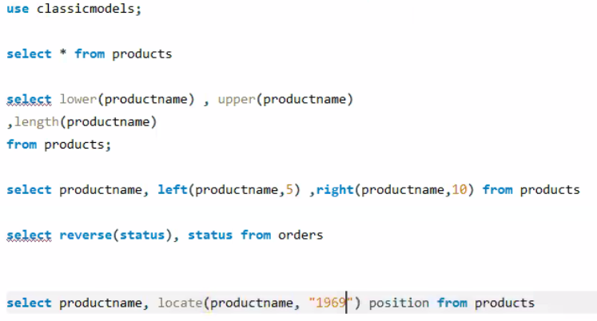

select lower(productname) , upper(productname)

,length(productname)

from products;

select productname, left(productname,5) ,right(productname,10) from products

select reverse(status), status from orders;

SELECT LOCATE('Harley','1969 harley davidson ultimate chopper') position;

select repeat('*', 50) ;

select substring(productname, 5) from products;

select substring(productname, -10) from products;

select substring(productname, 5,10) from products;

select substring(productname, -10) ,substring(productname, -10,5) from products;

SELECT FORMAT(12500.2015, 2),format(12500.2015, 0);

select creditlimit, format(creditlimit,2,'de_DE') from customers

SELECT

productname,

CONCAT('$',

FORMAT(quantityInStock * buyPrice, 2)) stock_value

FROM

products;

**timestamp**

SELECT DATE(now());

select day(now()) , month(now()), year(now()),week(now()),dayofweek(now()),

dayofyear(now());

Select date_format('2018-09-25', '%Y');

Select date_format('2018-09-25', '%M %d %Y');

Select date_format('2018-09-25', '%M');

select date_format(now(),'%H'),date_format(now(),'%h')

select date_format(now(),'%a');

Select datediff(date(now()),'2024-09-10');

select now();